**Assignment: 1**

Course Title: WST

Submitted To: Mr. Abo Bakar Aslam

Submitted By: Habiba Ali

Roll No:23014119-120

Section: A

Department: BS (computer science)



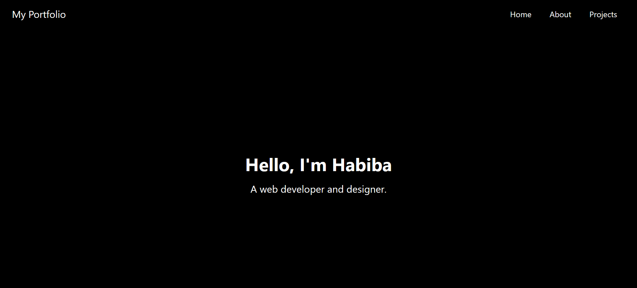

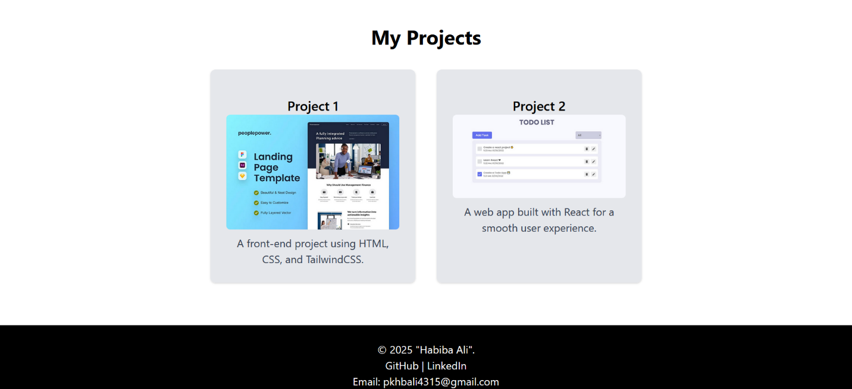

**Q1:** **Personal Portfolio Page (10 Marks).**

Create a personal portfolio webpage using HTML and Tailwind CSS. Your portfolio should include: A navbar with links to "Home," "About," and "Skills." An "About Me" section with a short description of yourself. A "Projects" section showcasing at least two projects with images and descriptions. A footer with social media links and contact information. Make the page responsive using Tailwind’s utility classes.

**Bonus (2 Marks):** Add a hover effect on the project cards using Tailwind CSS.

**Solution:**

<!DOCTYPE html>

<html lang="en">

<head>

    <meta charset="UTF-8">

    <meta name="viewport" content="width=device-width, initial-scale=1.0">

    <title>My Portfolio</title>

    <script src="https://cdn.tailwindcss.com"></script>

</head>

<body class="bg-white font-sans text-black">

    <nav class="bg-black py-4">

        <div class="container mx-auto flex justify-between items-center px-6">

            <a href="#home" class="text-white text-xl">My Portfolio</a>

            <div>

                <a href="#home" class="text-white px-4">Home</a>

                <a href="#about" class="text-white px-4">About</a>

                <a href="#projects" class="text-white px-4">Projects</a>

            </div>

        </div>

    </nav>

    <section id="home" class="bg-black text-white h-screen flex justify-center items-center text-center">

        <div>

            <h1 class="text-4xl font-bold">Hello, I'm Habiba</h1>

            <p class="mt-4 text-xl">A web developer and designer.</p>

        </div>

    </section>

    <section id="about" class="py-16 bg-gray-100 text-center">

        <h2 class="text-3xl font-bold text-black">About Me</h2>

        <p class="mt-4 max-w-2xl mx-auto text-gray-700">

            I'm a new web developer with a goal to become a professional :)

        </p>

    </section>

    <section id="projects" class="py-16 bg-white text-center">

        <h2 class="text-3xl font-bold text-black">My Projects</h2>

        <div class="mt-8 flex flex-wrap justify-center gap-8 px-6">

            <div class="bg-gray-200 p-6 rounded-lg shadow hover:shadow-xl transition w-full sm:w-1/2 md:w-1/3 lg:w-1/4">

                <h3 class="text-xl font-semibold mt-4 text-center">Project 1</h3>

                <img src="page.jpg" alt="Project 1" class="w-full rounded-md">

                <p class="mt-2 text-gray-700">A front-end project using HTML, CSS, and TailwindCSS.</p>

            </div>

            <div class="bg-gray-200 p-6 rounded-lg shadow hover:shadow-xl transition w-full sm:w-1/2 md:w-1/3 lg:w-1/4">

                <h3 class="text-xl font-semibold mt-4 text-center">Project 2</h3>

                <img src="todo.jpg" alt="Project 1" class="w-full rounded-md">

                <p class="mt-2 text-gray-700">A web app built with React for a smooth user experience.</p>

            </div>

        </div>

    </section>

    <footer class="bg-black text-white py-6 text-center">

        <p>&copy; 2025 "Habiba Ali".</p>

        <div>

            <p>GitHub | LinkedIn</p>

            <p>Email: pkhbali4315@gmail.com</p>

        </div>

    </footer>

</body>

</html>